**Torrens Primary School**

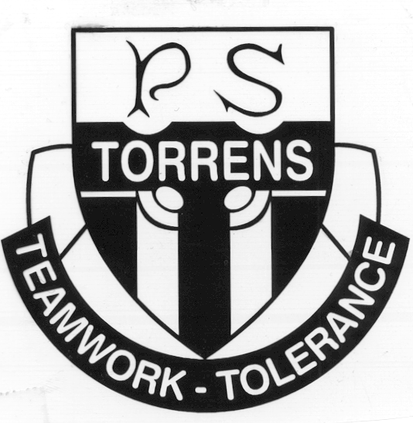

Ritchie Street

TORRENS A.C.T. 2607

Phone: 6142 0777 Email: [admin@torrensps.act.edu.au](mailto:admin@torrensps.act.edu.au)

Website: www.torrensps.act.edu.au

**YEAR 6 - CLASS OF 2021 GRADUATION JACKET**

**Cost:** $60.00

**Payment and order form due by:** Thursday, 18 March 2021 (Week 7)

**Payment options:** Online via school website or Eftpos only

--------------------------------------------------------------------------------------------------------------------------------------------

It has been the tradition at Torrens Primary School for the Year 6 cohort to wear a specially designed Graduation jacket in their final year. The 2021 jacket is a new design from previous years and incorporates:

- Bimbi, the Torrens Primary School PBL mascot on the front of the jacket

- Torrens Primary School shield on the front of the jacket

- student names printed on the back of the jacket within the ‘21’ number graphic

- the school colours of red, black and white, together with yellow

- a hood and heavier, warmer fabric

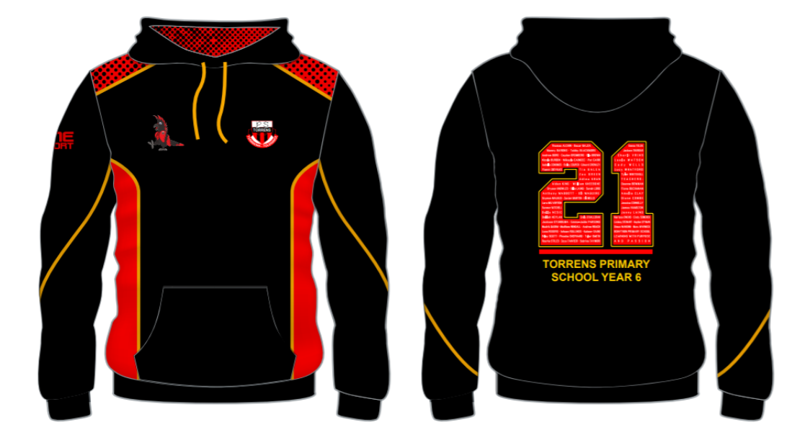

Purchase of the jacket is optional, but we do need all orders and payments to be in strictly by the due date to meet production requirements. We are currently waiting on sample sizes of the jackets to be available at the Front Office which will allow you to come in and correctly size your own child before putting in your order. Please note that Front Office staff cannot be responsible for selecting the jacket size for your child on your behalf.

Please complete the order details on the reverse of this form. If you are not purchasing a jacket, please still tick the appropriate box and return the form to school.

***Turn over for ordering and payment details***

**Torrens Primary School**



Ritchie Street

TORRENS A.C.T. 2607

Phone: 6142 0777 Email: [admin@torrensps.act.edu.au](mailto:admin@torrensps.act.edu.au)

Website: www.torrensps.act.edu.au

**YEAR 6 - CLASS OF 2021 GRADUATION JACKET**

**ORDER AND PAYMENT DETAILS:**

* I wish to purchase the Year 6 Class of 2021 jacket.



* I do not wish to purchase a jacket for my child.
* I DO NOT wish my child’s name to be printed on the jacket.

Student Name: ____________________________________________Class: ______________

Parent/Carer Name: _________________________ Signature: _____________Date: __/__/__

* On-line ([www.torrensps.act.edu.au/payment](http://www.torrensps.act.edu.au/payment)) Receipt No. _____________
* EFTPOS

**Office use:**

**Sized at Front Office on: ____/____/_____ Size selected: ___________ Qty: __________**

By: _________________________________