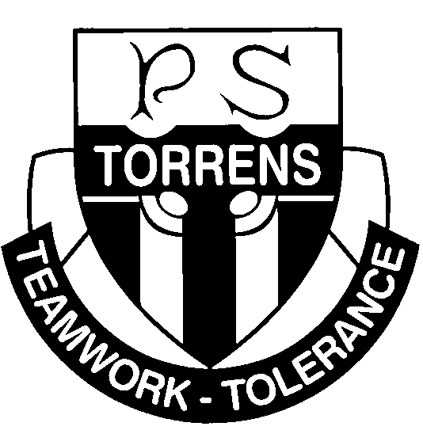
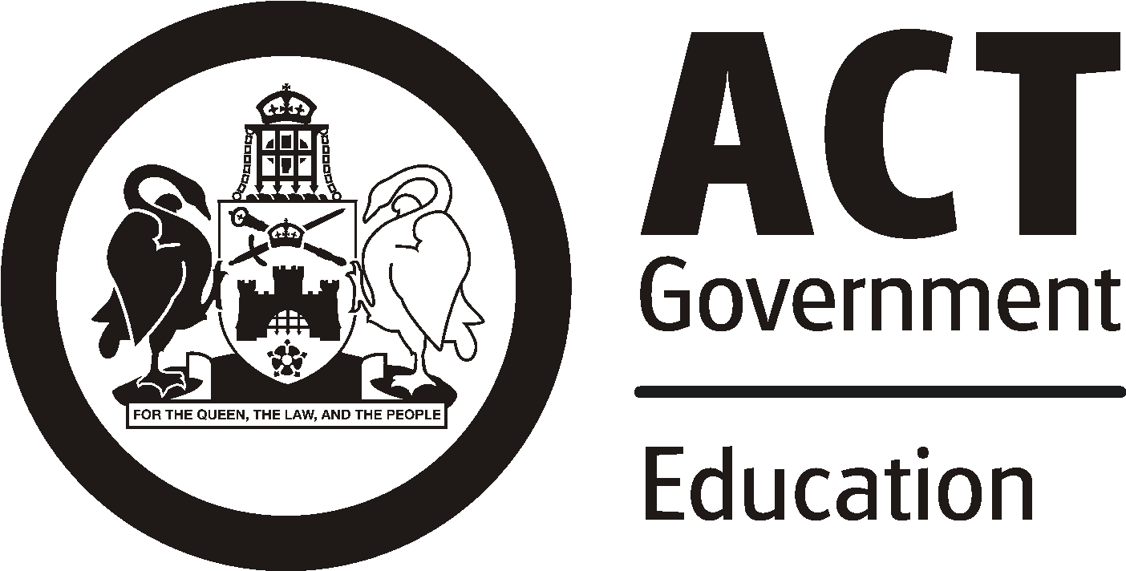
Torrens Primary School
Ritchie Street TORRENS ACT 2607
Phone: 6142 0777
Email: admin@torrensps.act.edu.au Web: www.torrensps.act.edu.au
13 May 2021
INCURSION: Year 5 Combined Band Practice at TORRENS Primary School
YEAR LEVEL: Year 5 Band
DATE OF INCURSION: Thursday 27th May 2021
TIME OF INCURSION: 9:45 – 11:15

The Year 5 band will be participating in their first combined band practice for 2021. This is an opportunity to meet like minded musicians from Monash PS. During this combined band practice students will be divided into instrument sectionals for expert tuition on their instrument. There will be no recess break so students will need to have a sustaining breakfast and bring a drink bottle.

The students will need to bring:
• Instrument
• Music
• Pencil / Journal

We are happy to be the hosts of this tremendous event.

The students will be playing pieces from their Sounds Innovations Book from pages 5, 6, 7 and possibly pages 8 and 9. We have been working on these pieces and they are progressing well. Thanks also to those parents that are keeping an eye on the weekly journal entries for home practice.

Unfortunately there will be no performance at this combined band practice.

Kind regards,

Kirrilee Turner
Year 5 band Teacher

