**Torrens Primary School** Ritchie Street TORRENS A.C.T. 2607

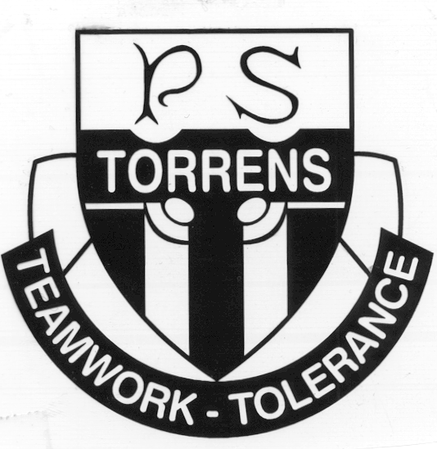

6142 0777 [admin@torrensps.act.edu.au](mailto:admin@torrensps.act.edu.au) www.torrensps.act.edu.au

**Incursion:**  Dion Drummond in-school performance

**Anticipated group size:** All staff and students across three performance times **Staff/Student ratio:** 1:16

**When:** Monday 6 June (Week 7) during school time

**Cost:** $6

*The school has made every effort to keep cost for this incursion at a minimum level. If necessary, parents or carers can confidentially discuss support to meet this cost with the Principal. Please contact the Front Office if you would like to speak with the Principal.*

**Payment and Permission slip due back to Front Office by:** Friday 3 June 2022 (Week 6)

*-------------------------------------------------------------------------------------------------------------------------------*

**Purpose of excursion:**

**In celebration of Reconciliation Week, Torrens Primary School will be hosting a visit from entertainer and educator Dion Drummond. Dion Drummond’s Aboriginal name is ‘Moogera’, meaning ‘storm’.** **He is of Torres Strait Islander descent on his mother’s side, and Aboriginal from his father’s side**. Dion was born in Mossman (Kuku-Yalangi Tribal area), 80km north of Cairns, Queensland.

Dion is one of Australia’s most experienced Indigenous performers, covering both Mainland and Islander culture as a dancer, singer and storyteller. **In his school visits, Dion shares tales and artifacts from his cultures, teaching students about the different traditions of both Torres Strait Island and Aboriginal storytelling, song and dance.** Students will participate in learning a little of the language, including some songs, as well as a look at the skills of Indigenous dancers.

Please complete the permission and payment section below and return by Friday 3 June (Wk 6)

----------------------------------------------------------------------------------------------------------------------------*----*

**Permission**

I give permission for my child to attend the in school performance by Dion Drummond on Monday 6 June 2022.

Child’s Name: ________________________________________________________________Class: ________

Name of Parent /Carer (Please print) _______________________________________________

Signature: _______________________________________ Date: *____ /_____/_____*

**Payment**

□ On-line ([www.torrensps.act.edu.au/payment](http://www.torrensps.act.edu.au/payment)) Receipt No. ______________ ,or

□ EFTPOS __/__/__