Welcome to Pearce Preschool for 2024 - Kookaburra Group – Monday/Tuesday (Wednesday)
Your child will need the following things each day at preschool:
Morning Tea
The children have morning tea during the morning.
We ask that the children have fruit/vegetables/other healthy food in a clearly labelled, small container. This is placed in an esky on the veranda.
Lunch
Please place your child’s lunch in a clearly labelled lunch
box or bag, separate to the morning tea container.
Please place their healthy lunch, in the eskies on
the veranda.
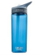
Drink Water only. Please provide a filled drink bottle, labelled clearly with your child’s name and place on the wooden stand.

Hat A bucket hat or wide brimmed hat is required throughout
the year at preschool. In the colder months, children may wear beanies/a warm hat. This hat can be kept in your child’s ‘home pocket’. Please label with a name.

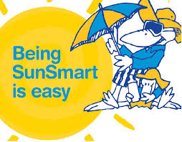
Apply sun lotion. In the warmer months, please apply sun lotion on your child before arriving at preschool. Sun lotion will be available at preschool for your child to reapply or have a small bottle of their own in their bag. Please let us know if you would prefer that your child does not use the preschool sunscreen due to skin sensitivity or allergy.

Clothing
Clothing worn to preschool should be comfortable and allow your child to engage in activities such as climbing, tumbling, painting, and digging in the sandpit and dirt.
A spare set of clothes should be kept in your child’s backpack in a named, labelled bag. For example, socks, underpants and seasonal extras (shorts & t shirt for summer; long pants & long-sleeved shirt for winter).
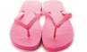
Footwear
Please ensure that your child wears shoes that are sturdy and fit well. Gumboots, thongs and Croc-style shoes are not suitable for preschool activities. Your child will have opportunities to be barefoot.
Please encourage your child to put their own shoes and socks on.

Backpack
Please ensure the backpack you choose is large enough to hold your child’s lunch box, drink bottle and spare clothes. Please put a name tag on the outside of your child’s bag.

Small Sheet or Pillowcase in a drawstring
bag for a designated ‘Quiet thinking time’. Please ensure your child’s name is written on both items. It will stay at school every day and be washed regularly.
Library Bag
Please provide your child with a cloth or plastic bag with two handles, large enough to carry a picture book. This bag should be clearly labelled with your child’s name.
Other Information….
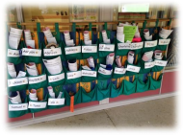
‘Home Pockets’
You may hear educators and children refer
to the ‘home pockets’. These are the cloth
pockets hung on the veranda and is where
your child’s hat will be kept. Notes and
artwork will be put here for you to take
home. Please check your child’s ‘home pocket’
each day.
Personal Items
We would prefer that valuables and sentimental items stay safely at home. However, we do understand that your child might like to bring in a special item when celebrating a special occasion.
Signing In and Out – not required
You are NOT required to sign your child in and out. Please check-in with educators if your child is late or you are picking them up early. Anyone listed on the Emergency Contact form will have permission to collect your child from preschool. If you arrange for other relatives/friend to pick up your child, you must inform the preschool in advance if they are not listed as an emergency contact. If we have not heard from you, we are unable to release your child to this person.
Class Times
Preschool begins at 9.00am and concludes at 3.00pm. It is important that your child is picked up on time.
We look forward to working with you in 2024.

