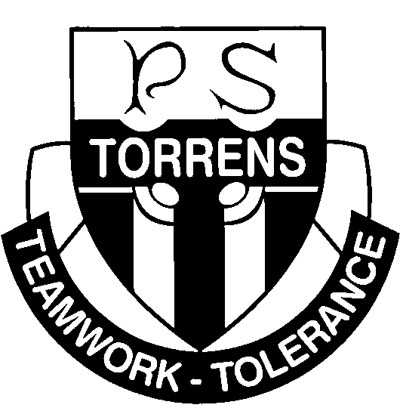
Torrens Primary School
Ritchie Street TORRENS ACT 2607
Ph: 6142 0777 admin@torrensps.act.edu.au www.torrensps.act.edu.au

2021 Wakakirri Story Festival - Expression of Interest
Dear Parents and Carers,

This year Torrens Primary School would like to once again participate in the Wakakirri Story Festival. Before making a final commitment to be involved in the festival we are seeking expressions of interest from all our Year 4 and 5 students. Students are invited to be involved as performers and backstage crew. This performance forms a valuable part of our music, dance, drama and literacy programs within the Australian Curriculum.

Wakakirri is a storytelling festival that aims to be a positive influence for children across Australia and, ultimately, to provide them with the artistic and creative opportunities they deserve through the performing arts. For more information on the Wakakirri Festival please refer to the website https://www.wakakirri.com
Students not participating directly in the Wakakirri program will be involved in a complimentary arts program. This program may involve the preparation of props and the painting of sets. Choosing to be in Wakakirri is a commitment to a total team effort. Many hours of hard work go into putting on a Wakakirri performance and it is therefore important that children who choose to be involved stay with the program through to the performance day.
Due to Covid-19 the performance format for Wakakirri in 2021 may be different to what we have experienced in the past. Wakakirri aims to still provide students with the opportunity to perform live on stage, however the performances may not be able to be open to the public. This is a decision that will be made closer to the event and will be dependent on Covid-19 restrictions applying at that time. As a result, Wakakirri have made the decision to live stream all performances this year. This will make the performances more accessible to many schools and families. On the performance day families, friends and the school community will be able to watch the performance live via their computer. Live streaming of performances will occur regardless of whether or not audience members are allowed.

WHEN AND WHERE
Dates for Wakakirri 2021 have not been finalised, however Wednesday 21 July (Week 2 Term 3) has been tentatively booked. Once this date has been confirmed we will let you know.

In the past, a full-dress rehearsal has been held at the Canberra Theatre on the day of our performance. Buses were organised to transport the children to and from the theatre for the rehearsal. Parents were required to organise transport for their child on the evening of the performance.

Please turn over page for more important information

This year, these arrangements may be different and will depend on whether or not there are audience members allowed. If there is no audience and the show is only to be live streamed, children may only be required to be at the Canberra Theatre during the day. Once again, we will provide more information on this when Wakakirri confirms with us.

COST
Torrens Primary School supports this endeavour, however due to the large number of students involved and the cost of putting on a performance of this size and quality, it is necessary to have our families contribute to costs. An amount of $50 will be collected from each student participating in Wakakirri to cover their travel by bus to the Canberra Theatre, participation fees (including insurance) and to assist with the cost of materials for costumes, makeup and props. Please note there will be an additional cost for tickets for viewing performances at the Canberra Theatre (should the performances be open to the public).

EXPRESSION OF INTEREST FORM

Please complete the attached expression of interest form and return to the front office by next Monday 15 March (Week 7). As this is an expression of interest no payment is required at this time.

We thank you for your support and look forward to a positive and rewarding Wakakirri experience.

The Torrens Wakakirri Team

Torrens Primary School
Ritchie Street TORRENS ACT 2607
Ph 6142 0777 admin@torrensps.act.edu.au www.torrensps.act.edu.au
2021 Wakakirri Story Festival - Expression of Interest

My child_____________________________________ in __________ (class) would like to participate in the 2021 Torrens Primary School Wakakirri Performance.

Please √ :

I agree to pay the $50 participation fee when this becomes payable.
I understand that due to Covid19 restrictions I may not be able to watch a live performance.
I understand live streaming may be the only viewing option in 2021.

________________________________ ___/___/___ Parent/Carer Signature Date

2021 Wakakirri Assistance

I/We can assist by (Please ✓tick all applicable):

Sewing costumes and donating

Assembling/Painting props/ backdrops

Fundraising

Hair and Make-up

Transporting backdrops and props
Please specify if you have any expertise in building sets etc, or if you have access to a vehicle large enough to transport props and backdrops to and from the theatre.

Name(s) __________________________________Contact Mobile/s ______________________

