Information for Parents/Carers: 2022 Year 4 Camp to Birrigai Outdoor Education Centre

When: Wednesday 19 October – Friday 21 October 2022 (Week 2, Term 4) - 9.30am – 2.45pm
Transport: Qcity Buses - departing Torrens Primary School

Group: 50 students and 5 TPS staff TPS Staff/Student Ratio - 1:10 Trip Leader: Kat Taylor
Cost: $300 per student - The school has made every effort to keep the cost for this excursion at a minimum level. If necessary, parents or carers can confidentially discuss support to meet the cost of the excursion with the Principal. Please contact the front office if you would like to speak with the Principal.

Permission, medical information and payment due: Thursday 22 September (Week 10) _____________________________________________________________________________________________
Purpose: Students will participate in a range of activities designed to support their learning of our Inquiry unit. Students will immerse themselves in activities linked to our Term concept ‘Perspectives’.

Activities: Students will be involved in team building adventure activities and environmental programs with a focus on Indigenous perspectives.

Contingency: If the excursion cannot go ahead for any reason, you will be notified well in advance by text message, Seesaw and email regarding alternative arrangements.
Important information:
- There is no mobile reception at Birrigai. The after-hours land line number at Birrigai is 6237 5135 (in the case of an emergency).
- The Year 4 teaching team, including Kat Taylor (trip leader and first aid) and Lou Zeitlhofer (Executive and first aid) will be attending Birrigai for the camp duration.
- A Recommended Packing List is included overpage. Please take special note of the subsection “Do Not Bring”.
- Accommodation is dormitory style.
- A teacher’s car will be on site for the two days of the camp.

Behavioural expectations: As with all school events we expect all students to adhere to Torrens Primary’s PBL values of being safe and respectful learners. Staff accompanying students on excursions will take all reasonable care while the students are in their charge to protect them from injury and to control and supervise their behaviour and activities.
Parents should be aware that staff members are not responsible for injuries or damage to property which may occur on an excursion where, in all circumstances, staff have not been negligent. Parents should warn children of the risk to themselves, to others and to property, of impulsive, wilful or disobedient behaviour.
Excursion Risk Assessment: available to view on request at the Front Office.

If you have any questions, please contact the classroom teacher via the Front Office.

The Year 4 Teaching Team

Recommended Packing List over page

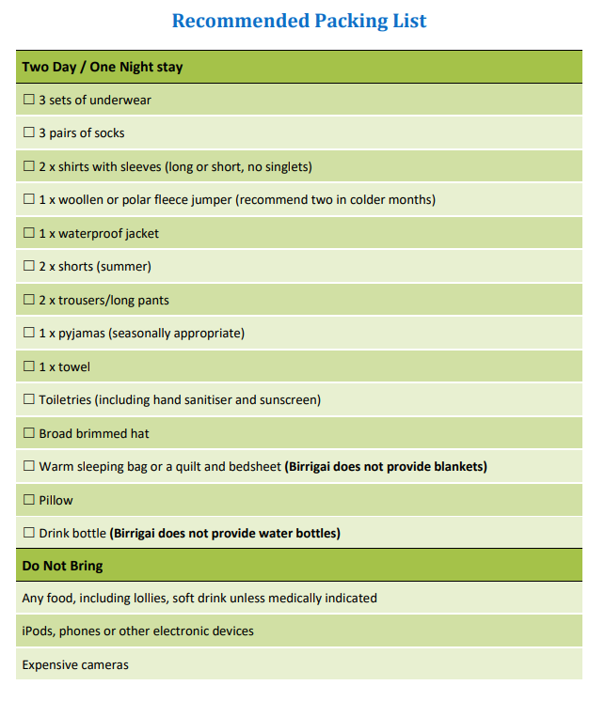

Permission for 2022 Year 4 Camp to Birrigai Outdoor Education Centre

I give permission for my child (name)__________________________ in Class _______ to attend the Year 4 camp to Birrigai Outdoor Education Centre, on 19th October-21st October 2022, travelling by bus as outlined in the Information for Parents/Carers note.
□ I have provided to the school all medical and dietary information relevant to my child attending this excursion, including the Birrigai Allergens/Restrictions form (if required) .
□ I have taken note of the recommended packing list, including the ‘Do Not Bring’ section.

I agree to my child participating in the activities associated with this excursion mentioned previously. I have discussed with my child the need for expected behaviour on this excursion. I authorise the school to make arrangements for the welfare of my child (including medical or surgical treatment) in an emergency and I agree to meet the associated costs.

I agree that my child will be under the authority of the school for the duration of the excursion and that the school is authorised to return my child to school or home at my expense if the school considers that circumstances warrant such action. I give permission for my child to travel by private car, driven by a staff member or parent, in an emergency.

Tick (√) or Cross (x) and complete all that apply:
□ You have previously completed the 2022 Medical Information and Consent Form for your child.
□ If your child’s medical information has changed since completing this Medical Information and Consent Form, please update this with the Front Office prior to the excursion. This may also involve completing the Known Medical Condition Response Plan.
□ If your child has specific dietary requirements related to medical conditions, food allergies or cultural food restrictions please complete the Birrigai Allergens/ Restrictions form attached.
□ If your child requires medication to be administered during the excursion (e.g antibiotics, asthma preventer, pain relief) please complete a Medication Authorisation and Administration Record available from the Front Office and provide medication to the first aid officer via the front office on the morning of the excursion. Note, medication you may have already lodged with the school as part of a Known Medical Condition will go with the first aid officer on the excursion.
□ In case of an emergency during the excursion:
Contact name: _________________________ Daytime contact phone number: ___________________

Medicare No: |  | Private Health Fund No: |  | Membership No:
Ambulance Fund: NOTE, Parents are responsible for ambulance costs outside the ACT.

Parent/Carer name:(print) ______________________Signature: ______________Date: _ /_/_

Please turn over for privacy and payment information

Payment details:-
Total amount due: $300
□ On-line (www.torrensps.act.edu.au/payment) Receipt No. __________,or
□ EFTPOS date paid: __/__/__

By completing the permission form, your personal information and that of your child will be collected and handled by the ACT Education Directorate (EDU). This information is necessary for us to manage student participation in excursions and support the welfare and safety of your child. If you do not consent to supply us with this information your child will be unable to participate in the excursion. Normally, we will not use or disclose this information for another purpose, without your consent, unless you would reasonably expect us to use or disclose the information for a related purpose. Normally we only share information with school staff and, where necessary, parents or volunteers assisting with the excursion to appropriately and effectively manage the excursion. The Directorate has a privacy policy that explains how we handle personal information, including how we handle privacy complaints. The policy is available on the Directorate’s website (www.det.act.gov.au) on the About Us page.

