**Torrens Primary School**

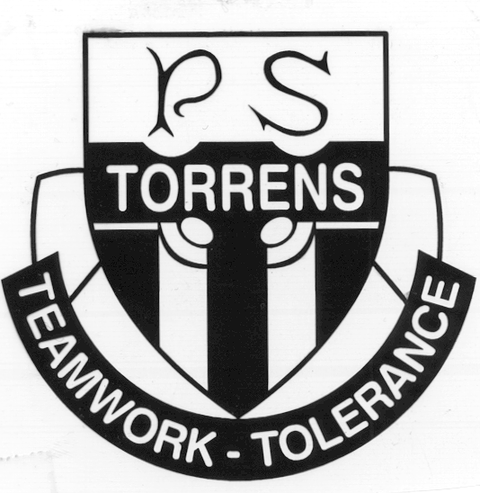

Ritchie Street

TORRENS A.C.T. 2607

Phone: 6142 0777 Email: [admin@torrensps.act.edu.au](mailto:admin@torrensps.act.edu.au)

Website: www.torrensps.act.edu.au

**Year 6 – Class of 2022 Graduation Jacket**

**Cost: $65.00**

**Payment and order form due by:** Thursday, 17 March 2022 (Week 7)

**Payment options:** Online via school website or Eftpos (via phone) only

--------------------------------------------------------------------------------------------------------------------------------------------

It has been the tradition at Torrens Primary School for the Year 6 cohort to wear a specially designed Graduation jacket in their final year.

The 2022 jacket (see graphic below) uses the design introduced last year, incorporating Bimbi (PBL mascot), the school shield, student names printed on the back, school colours, together with yellow, a hood and warm fabric.

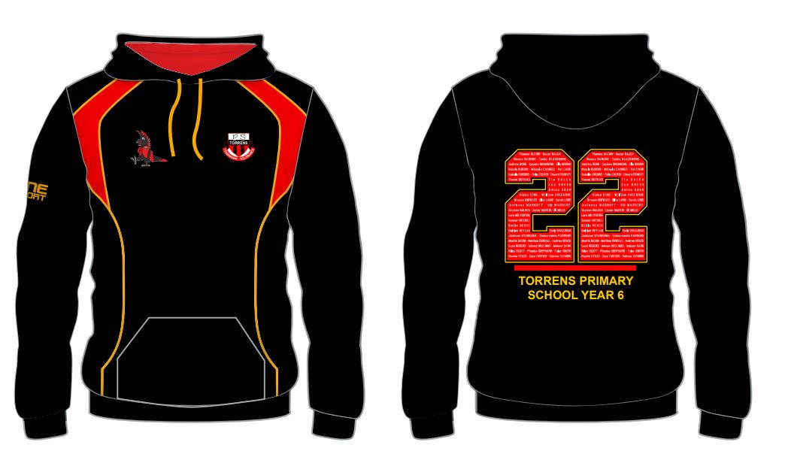

Purchase of the jacket is ***optional,*** but we do need all orders and payments to be in strictly by the due date to meet production requirements.

To stay in line with current covid safe protocols which preclude adults from being on site at the school, your child will shortly be able to ***try on sample sizes of the jacket in their*** ***classroom cohort*** as an additional check that the size you select on your order form is appropriate. Please therefore ***take special note of the sizing guide provided when placing your order, as incorrect sizes cannot be changed once orders are processed.***

Please complete the order details on the reverse of this form. If you are not purchasing a jacket, please still tick the appropriate box and still return the form to school.

***Turn over for size guide***

**Torrens Primary School**



Ritchie Street

TORRENS A.C.T. 2607

Phone: 6142 0777 Email: [admin@torrensps.act.edu.au](mailto:admin@torrensps.act.edu.au)

Website: www.torrensps.act.edu.au

**Year 6 2022 Graduation Jacket**

**Note:**

* When using the size chart below do not measure your child and compare to the chart. Always measure an existing similar garment your child fits into. Then follow the guide to measure that garment when laid flat on a table.
* In previous years the majority of orders were for a size 14 jacket
* Don’t forget your child will GROW during their senior year at Torrens Primary

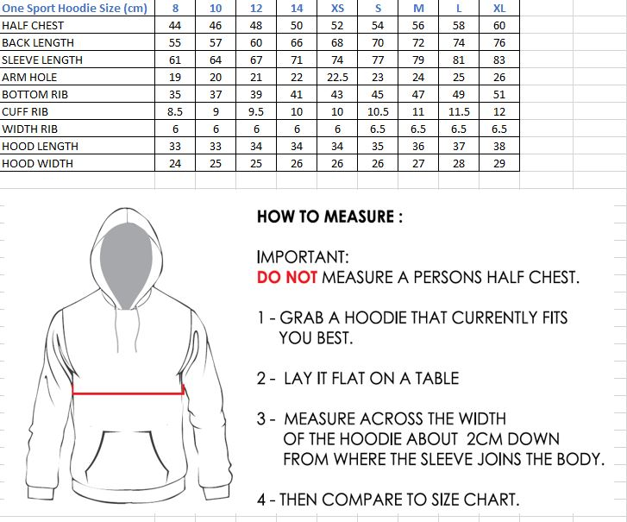

**Torrens Primary School**



Ritchie Street

TORRENS A.C.T. 2607

Phone: 6142 0777 Email: [admin@torrensps.act.edu.au](mailto:admin@torrensps.act.edu.au)

Website: www.torrensps.act.edu.au

**Year 6 – Class of 2022 Graduation Jacket**

**Order Form**

**Please tick (√) as appropriate and return this form to the class teacher by Thursday 17 March (Week 7).**

□I do not wish to purchase a jacket for my child.

□I wish to purchase the Year 6 Class of 2021 jacket.

□I DO NOT wish my child’s name to be printed on the jacket.

□I have used the size guide provided on the note and would like to order as follows:

Size:________________________________ Quantity:_______________________

Student Name: ____________________________________________Class: _______________

Parent/Carer Name: ____________________________________ Signature: _______________

Date: __/__/__

**Payment details:**

* On-line ([www.torrensps.act.edu.au/payment](http://www.torrensps.act.edu.au/payment)) Receipt No. _________________
* EFTPOS (please call the front office to make a payment over the phone)