**Torrens Primary School** Ritchie Street TORRENS A.C.T. 2607

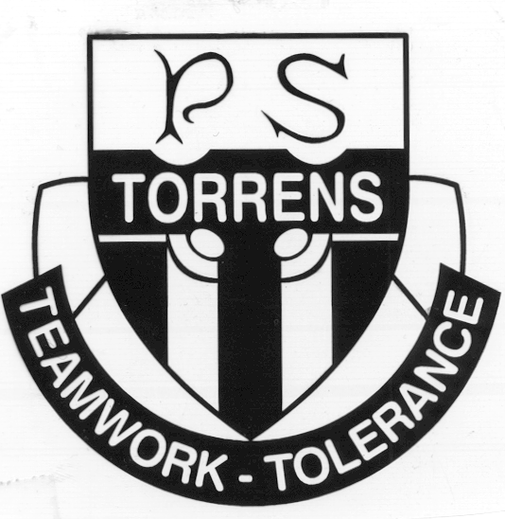

6142 0777 [admin@torrensps.act.edu.au](mailto:admin@torrensps.act.edu.au) www.torrensps.act.edu.au

**Torrens Primary School Cross Country Carnival 2022**

**Anticipated group size:** 20 staff; 280 students **Staff/Student ratio** 1:14

**When:** Friday 6 May 2022 **(Week 2)** - 11.35am – 1.00 pm

**Where:** This event will follow a course which takes in areas adjacent to the primary school grounds and the Torrens shops.

**Cost: $ nil**

**This permission note is due back to the Class teacher by:** Thursday 5 May 2022

*-------------------------------------------------------------------------------------------------------------------------------*

**Purpose & Activities:** The Torrens Primary School Cross Country Carnival provides the opportunity for students who are 8 years old and over to qualify for their regional Cross Country event.

**What to wear/bring & Contingencies:** Children should wear appropriate enclosed shoes/runners (no slip-on footwear/thongs) a hat and remember their water bottle. If arrangements need to change (eg due to bad weather) you will be informed via a text message to your mobile phone.

Our **COVID Safe Plan** will be in place which limits adults on site in the school grounds; however, if you can attend the carnival in an assisting capacity, please contact the front office first up to leave your name and contact details and we will get back to you.

**Staff who will be in attendance:** sports co-ordinator, class teachers, LSAs and first aid officer.

**Behavioural expectations:** *Staff accompanying students on excursions will take all reasonable care while the students are in their charge to protect them from injury and to control and supervise their behaviour and activities.*

*Parents should be aware that staff are not responsible for injuries or damage to property which may occur on an excursion where, in all circumstances, staff have not been negligent. Parents should warn children of the risk to themselves, to others and to property, of impulsive, wilful or disobedient behaviour.*

**Risk Assessment Document:** Available on request from the front office

If you have any questions regarding this event, please contact the Sports Co-ordinator, Justin Hughes, via the front office. Please return the completed permission form, including any new medical information (as required) by the due date above.

**Torrens Primary School** Ritchie Street TORRENS A.C.T. 2607



6124 0777 [admin@torrensps.act.edu.au](mailto:admin@torrensps.act.edu.au) www.torrensps.act.edu.au

**Torrens Primary School Cross Country Carnival 2022**

***(‘√’ tick all that apply)***

 I give permission for my child to run the **TPS Cross Country Carnival on Friday, 6 May from 11.35am until 1pm** starting in the school grounds and following a designated course surrounding the school.

*I agree to my child participating in the activities associated with this event mentioned previously. I have discussed with my child the need for expected behaviour, and I authorise the school to make arrangements for the welfare of my child (including medical or surgical treatment) in an emergency and I agree to meet the associated costs. I have provided to the school all medical information relevant to my child participating in this event.*

*I agree that my child will be under the authority of the school for the duration of the event and that the school is authorised to return my child to school or home at my expense if the school considers that circumstances warrant such action. I give permission for my child to travel by private car, driven by a staff member or parent, in an emergency.*

**You should have already completed a *Medical Information and Consent Form*.** This form only needs to be completed once annually unless there are changes to the details on this form. Are there any changes to this form?

Yes  No   If yes, an updated *Medical Information and Consent Form* is required to be completed. (Download from the website: <https://www.torrensps.act.edu.au/our_school/general_medical_information> *Note:* if you have not provided a form for 2022 to the school, please download and complete now to return with this permission note.)

Will your child require medication to be administered during the event (e.g., antihistamine, pain relief)?

Yes  No  If yes, please complete a *Medication Authorisation and Administration Record.* (Download from the website using the above link).

Is there any additional information you need to provide to support your child’s participation in this event?

Yes  No  If yes, please provide these details: __________________________________________________________________________________________________________________________________________________________________________

**Child’s Name: _________________________________________________Class: ___________**

**Name of Parent /Carer (Please print): ______________________________________________**

**Signature: _____________________________________________ Date: *____ /_____/_____***

By filling in the attached form, your personal information and that of your child will be collected and handled by the ACT Education Directorate (EDU). This information is necessary for us to manage student participation in excursions and support the welfare and safety of your child. If you do not consent to supply us with this information your child will be unable to participate in the excursion. Normally, we will not use or disclose this information for another purpose, without your consent, unless you would reasonably expect us to use or disclose the information for a related purpose. Normally we only share information with school staff and, where necessary, parents or volunteers assisting with the excursion to appropriately and effectively manage the excursion. The Directorate has a privacy policy that explains how we handle personal information, including how we handle privacy complaints. The policy is available on the Directorate’s website (www.det.act.gov.au) on the About Us page.