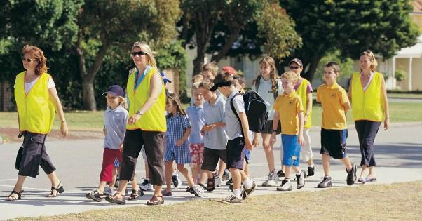

Who are we?
The Torrens Primary School Parents and Citizens (P&C) Association is the focal point for parent involvement at the school (P-6) and provides a place for parents to discuss and debate matters of interest relating to the school and community. It is also a great way to meet other parents and better understand how the school works and what is offered for the children to take part in.
All parents or guardians of children at Torrens Primary School and our preschools are automatically members of this P&C.
The P&C holds regular evening meetings throughout the school year. All parents and carers are welcome to attend, hear about what is happening around the school, propose ideas, and participate.

What do we do?
The P&C provides strong community support for the school by encouraging parents to be involved in the workings of the school.

We run many events and provide a number of services for students and families. These include:
- Class Representative Network to assist families to connect with each other and the school.
- The second-hand uniform shop
- School discos
- Social events for parents, such as our annual trivia night
- Mother’s Day and Father’s Day stalls
- Book Club
- Fundraising to provide improvements to the school and new resources for students.
- Input into ACT school policies via the ACT Council of P&C Associations.

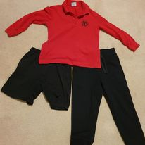

Get involved
The P&C values the diversity of skills and experiences that each family brings to the school and we know that school is better for kids, teachers and families when we get involved.

Ways you can help include:
- Help at P&C events
- Assist at school sporting events
- Help at the second-hand uniform shop
- Attend P&C meetings or participate on P&C sub-committees
- Run a fundraising or community event
- Cook at community BBQs
- Be a Class Representative
- Become a Council delegate
To find a job that suits, you might like to come along to a P&C meeting or join our email distribution list.
To join the email list, or if you have any questions, or can volunteer just email torrenspnc@gmail.com
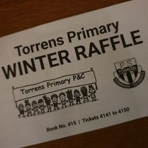

Contacts

To find out more about the P&C,
visit the P&C section of the School web site:

http://www.torrensps.act.edu.au/our_community/p_and_c

or email torrenspnc@gmail.com

The P&C also has an email distribution list which we use to send information and occasional calls for help. To join the list, send an email to torrenspnc@gmail.com.

Join us on Facebook
https://www.facebook.com/TorrensPrimarySchoolPandC

More information about what P&Cs do can also be found at the ACT Council of P&C Associations www.actparents.org.au.

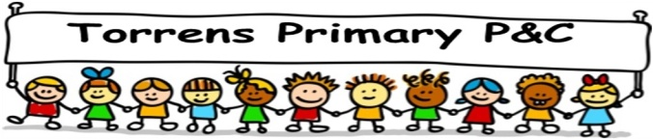

Torrens Primary P&C Association

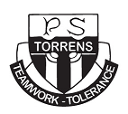

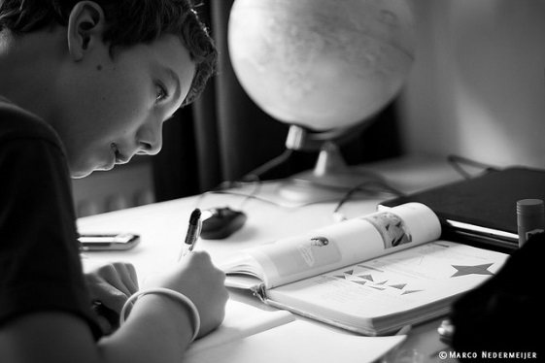
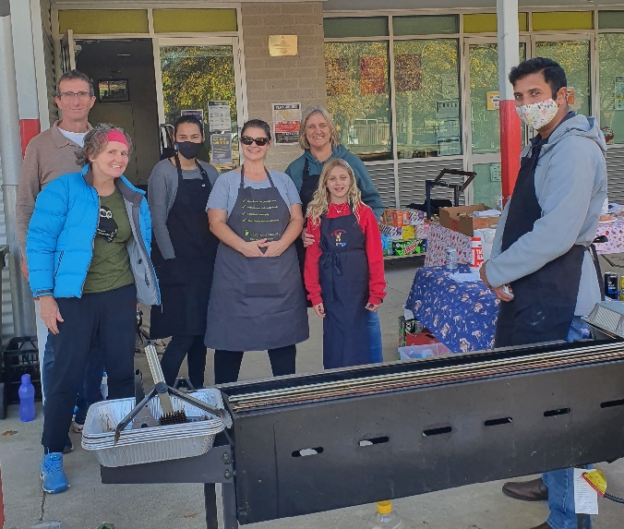

Benefits of participating
P&C activities create opportunities for parents and carers, students and staff to interact, building a feeling of respect and a stronger, safer, school community.

When you participate, you benefit by:
- meeting other parents in the community
- understanding more about what happens at school
- getting to know the teachers better
- sharing your skills with other parents/teachers and learning new ones
- setting a good example for your children

Your children will benefit too. Research shows that when parents are involved, students get better grades, have a better attitude to school and improved behaviour!

