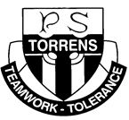

Torrens Primary School

Handbook

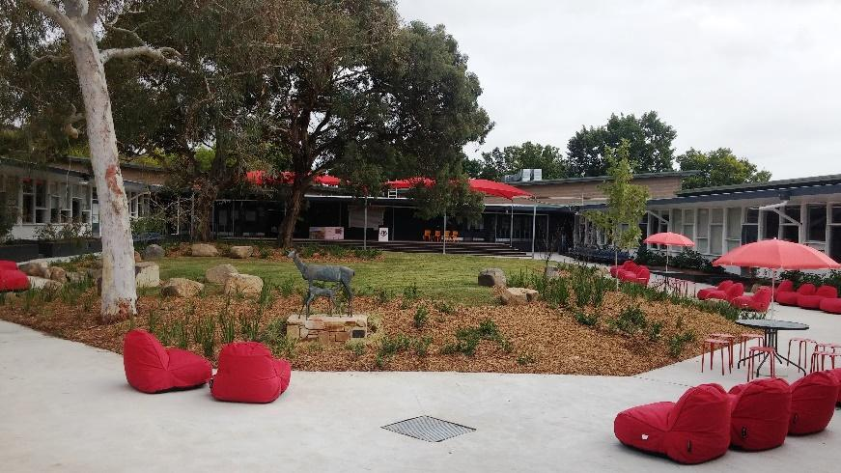

Principal: | Rachel Matthews
Address: | Ritchie Street  Torrens ACT 2607
Phone: | (02) 6142 0777
Email: | admin@torrensps.act.edu.au
Web: | www.torrensps.act.edu.au
REPORT ABSENCES : | Phone (02) 6142 0777, or email -  admin@torrensps.act.edu.au, or complete the online form at https://torrensps.schoolzineplus.com/form/3

Contents
Principal’s Welcome 3
Vision 4
Mission 4
Our Values & Improvement Priorities 4
History of Torrens Primary School 5
Australian Curriculum 6
Assessment and reporting of student progress 9
Specialist staff, programs and activities 10
Health, wellbeing and management of medical conditions 13
Important health and medical forms 13
Community involvement at Torrens Primary School 15
Volunteering 15
The Parents and Citizens Association (P&C) 15
School Board 16
School Policies 17
Student Management 17
Positive Behaviours for Learning (PBL) 17
Home Learning 17
Sun Protection 18
Dress Standard and Colour Code Policy 18
Information Communication Technology (ICT) 18
Administration 20
School Hours, Before and After School Care 20
School Organisation and Houses 20
School Uniform 20
Stationery Requirements/Book Packs 21
Attendance, absences and pick up during school hours 21
Appointments with teachers 21
Assemblies 22
Buses 22
Food during the day – Health Break, Recess, Lunch, filled water (only) bottle 22
Library 22
Lost Property 22
Messages, deliveries, money collection 23
Newsletter and notes home 23
Parking and road safety around the school 23
Updating your personal information 24
Visitors, Volunteers and Parents 24
Website www.torrensps.act.edu.au 24

Principal’s Welcome
Welcome to Torrens Primary School! Torrens is a vibrant, colourful P-6 school set in spacious grounds. Torrens Primary School enjoys strong community involvement and support in all aspects of school life. The partnership between school and home is extremely important to develop and foster high academic achievement, meaningful relationships and a love of learning in our students.
At Torrens Primary School teamwork and tolerance are promoted. High quality educational and extra curricula programs are presented by a dedicated and involved team of staff. Torrens Primary School is known for the range of incredible opportunities offered to students throughout their years here. We are part of an active cluster. Along with Mawson and Farrer Primary Schools, we work with Melrose High School and Canberra College to offer outstanding transition programs.
At Torrens Primary School we cater for a broad range of individual differences including gifted and talented students and students with additional needs. Emphasis is also placed on providing the best possible start during the first years of schooling. Early intervention programs include the development of early literacy and numeracy skills through an active support team led by the Deputy Principal. The team includes our Executive teachers, School Psychologist, English as an Additional Language or Dialect (EALD) teacher, Learning Support Assistants (LSAs), parents and special interest partners such as The Smith Family, Woden Community Services, Schools Volunteer Program and more.
Torrens Primary School is a resilient, thriving social democracy. Together we are building an inspiring and inclusive vision. The staff, students and community are united in working towards excellence in education, promoting diversity and nurturing a culture of wellbeing. Everyone is celebrated as an individual. Plans are personalised. Learning is differentiated. Students are engaged in their learning. Positive outcomes are achieved. Our collegial nature places a high priority on trust, collaboration and positive relationships. There is a sense of belonging and pride at Torrens Primary School. Welcome to the journey.
Every learner. Every day.
Rachel Matthews – Principal
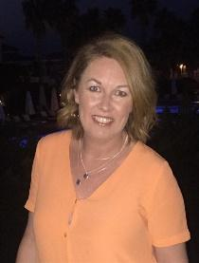

Vision
Torrens Primary School, while valuing elements of traditional educational approaches, recognises the need to incorporate current advances in curriculum development, teaching and learning styles and strategies and educational resources in order to develop quality educational programs which meet the needs of our students in a constantly changing world.

Mission
Torrens Primary School provides a purposeful, productive and comprehensive education of the highest quality, working in partnership with the school community. The school aims to provide quality experiences that empower students to live in, and contribute to, a changing society. Torrens strives to develop in students the ability to work as members of a team in cooperative learning environments, and to appreciate the worth of individual differences, with the capacity to act as responsible, independent citizens who care about themselves and their environment.

Our Values & Improvement Priorities
School Values: Teamwork and tolerance
Priority 1: Improve growth in writing to establish a community of engaged writers.
Priority 2: Improve growth in mathematics, establishing a community of engaged mathematicians.

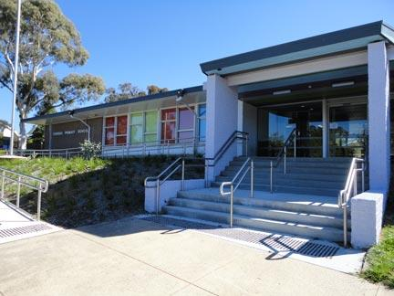

History of Torrens Primary School
The suburb Torrens is named after a former Governor of South Australia, Sir Robert Torrens. Torrens Primary School was opened in 1968.
The School’s badge and motto were devised after a student competition. The badge consists of a heraldic shield together with the motto Teamwork and Tolerance.
The School House names of Fraser, Wenden, Clarke and Devlin were established in response to a survey of the most popular sporting identities of the time (1968) - being swimmers Dawn Fraser and Michael Wenden, athlete Ron Clarke and golfer Bruce Devlin.
The school celebrated its 50th Anniversary in 2018.

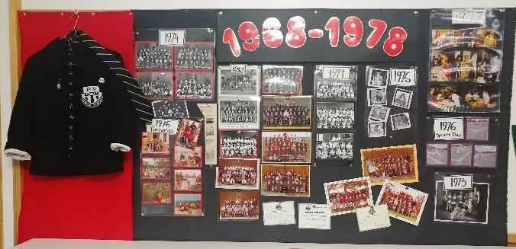

Torrens School Song - Words and Music by Burt Ansell
These are the days we remember all our lives,  They show the ways that will help us better to survive.  All the new-found knowledge we learn each day,  We will share gladly in every way. | Throughout the years, the importance of these words,  Becomes more clear as we strive to understand our world.  With the best of help we will surely find,  Happiness and love with peace of mind.
Because Torrens has teamwork to  Help us work together.  Torrens has tolerance to be with us forever and a day,  Come what may. | Because Torrens has teamwork to help us work together,  Torrens has tolerance to be with us forever and a day,  Right to the end, we have our friends.

Australian Curriculum
Torrens Primary School implements the Australian Curriculum (AC). Curriculum areas are:
English
All teachers at Torrens teach English, which is divided into three main areas:
- listening and speaking
- reading and viewing, and
- writing
Students are encouraged to observe and reflect upon texts, and to create and present texts in these areas, focusing on the literacy, literature and language of English.
In the early years, students learn to speak, read and write and move towards the ability to speak, read and write to learn. Throughout all years at Torrens, correct grammar, spelling and structure of English is modelled, explicitly taught, discussed and practised.
Overview of the English curriculum is one of the responsibilities of the Executive Team. The need for programs, staff development and student support are identified through discussion, testing and assessment so that the best possible teaching and learning in English occurs.
Mathematics
Mathematical concepts and processes are organised into the following strands:
- numbers and algebra
- measurement and geometry
- statistics and probability
- understanding, fluency, problem solving and reasoning
Science
There are three interrelated strands taught:
- understanding – biological sciences, chemical sciences, earth and space sciences, physical sciences;
- Science as a human endeavor - incorporating the nature and development of science, its use and influence; and
- Science inquiry skills – questioning and predicting, planning and conducting, processing and analysing data, evaluating and communicating.
Together, the three strands of the Science curriculum provide students with understanding, knowledge and skills through which they can develop a scientific view of the world. Students are challenged to explore science, its concepts, nature and uses through clearly described inquiry processes.

History
The focus in Kindergarten to Year 2 is on awareness of family history and community heritage. Students learn about their own social context of family, friends and school, and the significance of the past. They engage with the remains of the past; develop a concept of time as present, past and future and, through role play, use their imagination to speculate about the lives of others in the past.
In the Senior school the focus is on local and national history and use of a range of sources. Students develop their understanding of the world and their relationship to others, past and present. Students begin to better understand and appreciate different points of view and to develop an awareness of justice and fair play.
Geography
Geography is organised into two related strands:
- geographical knowledge and understanding, and
- geographical inquiry and skills
Geography teaches students to respond to questions in a geographically distinctive way. They plan inquiries, collect, evaluate, analyse and interpret information and suggest responses to what they have learnt. Students have opportunities to develop a wide range of general skills, capabilities and dispositions that can be applied in everyday life. Students develop information and communication technology skills; an appreciation and respect for social, cultural and religious diversity and different perspectives; an understanding of ethical research principles; a capacity for teamwork, and an ability to solve problems and to think critically and creatively.
Civics and Citizenship
The Civics and Citizenship curriculum is all about ensuring students have the skills and values to become active and informed citizens. Students will investigate political and legal systems, and explore the nature of citizenship, diversity and identity in contemporary society.
The Civics and Citizenship curriculum is designed to foster students’ commitment to national values of democracy, equity and justice. This curriculum will develop students’ appreciation of Australia’s diversity and what it means to be a citizen. It explores ways in which students participate in Australia’s civic life and make a positive contribution as local and global citizens.
Performing and Visual Arts
Students can participate in brass bands (Years 5 and 6), dance, singing, public speaking and performing throughout the school, including at class and year level assemblies. Students also have the opportunity to participate in public performances outside the school, most notably in the National Wakakirri Story Dance Competition (Years 4 and 5).
Teachers at Torrens Primary School provide a broad range of performing and visual arts lessons to all students in their classes following the Australian Curriculum.

Design and Digital Technologies
Students apply knowledge, experience and resources to design, make, use and appraise products for specific needs.
Coding is taught in all year levels, and students in Kindy to Year 2 learn touch typing to assist them with online NAPLAN testing.
Health and Physical Education
The aim of Health and Physical education is to:
- develop students’ capacities to make decisions and act in ways that promote their health and that of others;
- focus on the important role physical activity plays in the lives of all students by providing opportunities for personal growth, enjoyment and challenge; and
- promote understanding and valuing of one’s personal identity and development and the need for positive relationships.
The learning areas are organized into three strands:
- the student acts to promote health;
- the student is physically skilled and active, and
- the student manages self and relationships.
Language Other Than English (LOTE)
This area of the Australian Curriculum is designed to enable all students to engage in learning a language in addition to English. Students learn to recognise the features that languages share, as well as the distinctiveness of specific languages. Since 2022, Japanese has been the LOTE taught at Torrens Primary School.

Assessment and reporting of student progress
At Torrens Primary School we provide regular, accurate and comprehensive information about a student’s intellectual, social and personal development and indicate areas for further development.
Written reports regarding student progress include an A-E achievement grading (not for Preschool or Kindergarten) as required by the Government Schools Education Committee (GSEC). Kindergarten students receive the BASE Report instead of A-E reporting.
Students across the school and preschools can also access their class activities and other communication in real time via the Seesaw App, instead of waiting for a portfolio at the end of the year.
Reporting each term at Torrens is summarised in the table below, but if you are concerned about your child’s progress at any time during the year, please make an appointment to meet with the class teacher.

Term 1  - Information evening  - Term Overview  - Individual Learning Plan (ILP) meetings for students with special needs  - Learning Journey  - Kindergarten BASE Report  - Seesaw | Term 2  - Term Overview  - Seesaw  - Mid-year Report (emailed)  - Parent/teacher interview
Term 3  - Term Overview  - Seesaw  - In school review and appraisal meetings for students with special needs  - Learning Journey  - NAPLAN (Years 3 and 5)  - ILP Review meetings | Term 4  - Term Overview  - Seesaw  - Kindergarten BASE Report  - End of Year Report (emailed)  - Parent/teacher interview

Specialist staff, programs and activities
At Torrens Primary School students spend most of their time with their class teacher. Some classes are taken by specialist teachers. In addition to dedicated specialist teachers for LOTE and Physical Education, other support programs and staff include:
English as an Additional Language or Dialect (EALD)
The aim of the EALD program is to develop the abilities of students from a non-English speaking background to understand and use oral and written English. Individual programs are designed to enable these students to reach a level of competence which will permit them to continue their language development in a mainstream class.
Literacy and Numeracy Support Program
The Literacy and Numeracy Team works in conjunction with classroom teachers to address specific needs of students by means of in class, small group or individual extra assistance. School wide literacy and numeracy tests are used to inform the support provided across all year levels. The program is coordinated with other support programs (e.g. EALD, Gifted and Talented) for students who are identified as having special gifts and talents as well as those who are not yet achieving at year level.
Gifted and Talented
Torrens has a big focus on gifted and talented students, with programs and resources including staff professional learning from international consultants, standardised testing, individual programs, cluster enrichment days as well as one-on-one and small group extension.
Librarian
The Librarian at Torrens Primary School is responsible for the maintenance and loaning of the school’s information resources. Library classes focus on the development of information literacy skills and literature appreciation. The Librarian coordinates a range of activities for Book Week each year at Torrens and organises author visits and literary workshop incursions.
School Psychologist
A Psychologist visits the school on a regular basis and works closely with all members of staff. The Psychologist is available for consultation regarding student specific cases and parents may arrange interviews by phoning the school in the first instance.
Kitchen
Students get to develop their food technology skills cooking in the kitchen with our Teacher/Chef. They learn about nutrition and how to keep themselves healthy and safe in the kitchen.

Excursions
Excursions, which may include camps in the senior school (years 3, 4, 5 and 6), are important learning experiences which take students beyond the school grounds and add context to units of work studied in the classroom. Information detailing excursion purpose, dates and times, costs (if any) and other details are sent home well before the outing. Written permission, including updated medical information where required, is sought for all excursions. Excursion information is placed up on the school website (‘calendar’ and ‘notes’ tabs) and in the online school newsletter for you to easily access.
Enrichment
Staff at Torrens Primary give up their lunchtimes to offer students several activities such as Yoga, dance, library, gardening, soccer, writing club, scooters, games, netball and more.
In addition to sports carnivals and cross-country events each year at Torrens, students may also get to participate in Learn to Swim and gymnastics clinics, sporting clinics, gala days and sport sessions with Melrose High or Canberra College students.
Students are also given appropriate guidance and encouragement to participate in state and national competitions in maths, English, science and computing. Senior students may compete in the Rostrum school based public speaking competition.
School wide activity days engender school spirit and a sense of community and include celebrations for Reconciliation Day, NAIDOC Week, Harmony Day, Book Week and Just 50 Words Literacy.
At Torrens Primary we are lucky to have access to music tutoring in piano during school hours on a parent-pays basis. More information is available from the Front Office or on the school website.
Transitions
To ensure smooth transitions throughout your child’s journey at Torrens Primary, the following opportunities to meet other children in their cohort and other parents and carers are provided:
Stay and Play mornings may occur weekly in Term 4. To transition children ahead of their preschool or Kindy year, Parents are invited to bring their preschoolers and younger siblings to the primary school for a morning of activities. Parents and carers can meet each other. Children can become familiar with their peers and the school environment. These mornings are provided via Woden Community Service (WCS).
Preschool to Kindergarten transition days occur in Term 4. While children are assigned to classes to ‘try Kindy for a day’, parents attend an information session, receive a tour of the school, can purchase second hand uniform items at the P & C uniform store, and enjoy morning tea in the Wellbeing Courtyard.
Students who have been attending our cluster language schools for intensive English classes will come to our school for one or two (1 or 2) transition days prior to starting full time with us.
Transition to high school begins for students in Year 5 and continues into Year 6 with cluster events such as the Thinking Carnivals, leadership conferences and workshops. Transition to high school for Aboriginal or Torres Strait Islander students and students with additional needs is also arranged.
The Smith Family’s Passport to Success program may also run to help Year 6 students transition to high school.
Student Parliament
The Student Parliament is made up of Year 6 students who take on ministerial roles, including the Minister for the Environment, The Minister for Indigenous Affairs as well as a Minister for each Year level. The issues raised in Parliament are taken to the Principal and Executive for consideration.

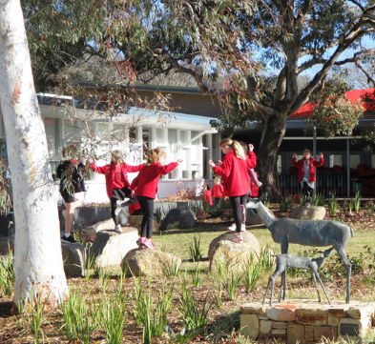

Health, wellbeing and management of medical conditions
Illness
Children who are unwell are unable to enjoy school and if they attend, they run the risk of spreading illness. Please keep your child at home if they are unwell and notify the school of their absence.
Please inform the school if your child has a contagious or infectious disease. Please refer to the Education website (https://www.education.act.gov.au/home) for information relating to disease exclusion periods and COVID19 specific updates.
Sick bay, first aid and ambulance transportation
If a child becomes unwell at school, they will be admitted to the sick bay and if necessary a parent or carer will be contacted. You are notified immediately if a child has a serious accident at school. Staff trained in first aid will administer first aid treatment if required and all details of sick bay admissions and treatment are recorded on the school’s database.
Children who are injured in a school accident during school hours are transported free of charge by the ACT Ambulance Service to an ACT public hospital. Parents and carers are reminded to check their health cover for ambulance transportation outside the ACT as charges may apply before and after school hours.
Management of medical conditions
The Directorate is committed to providing a safe and healthy environment for students. While school staff have a duty of care to students to provide first aid assistance when required, parents will be aware that schools cannot be responsible for the general management of medical conditions.
In special circumstances, staff may be able to assist with the administration of medication. In these cases, Directorate policy requires principals to ensure that a comprehensive written authority is obtained from the student’s parent or carer.

Important health and medical forms
Please take special note of the following forms which we require you to complete and submit to school should your child require medical attention while at school:
Medical Information and Consent form
You are asked to complete this form on enrolment and at the beginning of each school year to keep records up to date. The form asks for general medical information and consent for first aid and the administration of the authorised medications for life-threatening asthma (Ventolin) or anaphylaxis (adrenaline). A new Medical Information and Consent will also be required ahead of your child attending any excursion should their medical needs have changed since completion of the form on enrolment or at the beginning of the school year.

Known Medical Condition Response Plan
This is required for any student with a known medical condition. It provides instructions for the management of an identified medical condition (such as Diabetes, Asthma, Anaphylaxis or Epilepsy) and should be completed in consultation with the treating health professional.
Medication Authorisation and Administration Record
This must be completed and returned to the Front Office should medication be required to be administered at school. Medication must be clearly labelled and in its original packaging, with times for administration clearly stated.
Safety at Torrens
Potentially dangerous toys and equipment should not be brought to school. This includes toy weapons for News or play. The fixed playground equipment is not supervised by staff before or after school. Students should only use playground equipment at these times when a parent or carer can supervise them.
Students are supervised by teachers from 8.45am onwards. Students are to depart school grounds promptly at 3.15pm.
Head Lice
While head lice are extremely contagious, they are a very normal part of school life and easily eradicated. You as parents and carers can assist in the prevention and management of head lice outbreaks at school with regular checks of your child’s hair. If your child does have head lice at school, you will be contacted to come and collect in order that treatment can be commenced. Should an infestation of head lice occur at school a general note will be sent home (usually via Seesaw) to all students in affected classes requesting you to check and, if necessary, treat your child’s hair. The ACT Health Head Lice Fact Sheet is available on the school website.
All medical forms and fact sheets outlined above are available for download from the school website: www.torrensps.act.edu.au.

Community involvement at Torrens Primary School

Volunteering
Torrens Primary School works in partnership with parents and community members to provide an educational program and facilities of the highest quality. Helping at school is a great way to get involved in your child’s education and to get to know the school staff and other parents. Research shows that children benefit when their parents are actively involved in their education and school life. From time to time notes may go home from class teachers or be placed in the school newsletter outlining volunteering opportunities.
Here are some ways you can help:
- listen to children read in the classroom;
- support the home reading program;
- volunteer on sports days;
- excursion supervision;
- fundraising activities;
- join the P & C or School Board; or
- share your knowledge and skills with the students by presenting in the classroom.
If you wish to volunteer more than three times in one month, or seven times in a year, you are required to obtain a “Working with Vulnerable People” card and carry this with you when in the school. You will also need to complete a Volunteers and Visitors in Schools Nomination Form (available on request from the Front Office or download from the school website).
More information for volunteers and visitors is available on the Directorate’s website, including links to Access Canberra’s Working with Vulnerable People page:
https://www.education.act.gov.au/public-school-life/get-involved-in-your-childs-school/volunteering

The Parents and Citizens Association (P&C)
The role of the P&C is to:
- promote school interests;
- encourage cooperation and community involvement;
- fundraise for educational, recreational and sporting equipment for the school;
- provide a forum for parents to discuss educational matters; and
- run the school’s second-hand uniform shop.
More information is available on the enclosed P&C brochure and in the Torrens Times newsletter. 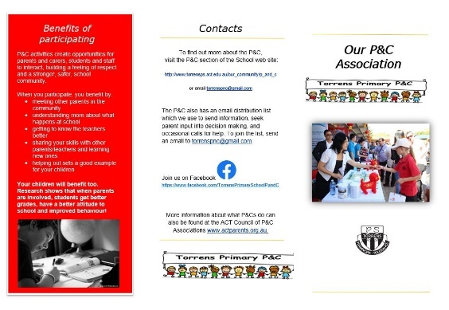

School Board
The School Board is the policy making body of the school. The Board consists of members elected by the school community, teachers elected by the staff of the school, the Principal, and may include an ACT Government representative.
The major functions of the Board are:
- formulating educational policy;
- approving the school budget;
- liaising directly with the community and school to authorise the level of the voluntary contributions requested from families. The second major source of income for the school (after Commonwealth and ACT Government funding for basic materials and building maintenance) comes from voluntary contributions made by families. This money is used for maintaining and extending curriculum areas and providing extra materials and resources used in the library or classrooms.
- oversight of curriculum requirements in line with the Australian curriculum.
Board members are eager to hear parents’ views and welcome discussion of any topic which comes within their jurisdiction. Their main concern is the provision of the best educational opportunities for every child at Torrens Primary School. School Board meetings are held at least four (4) times per year.
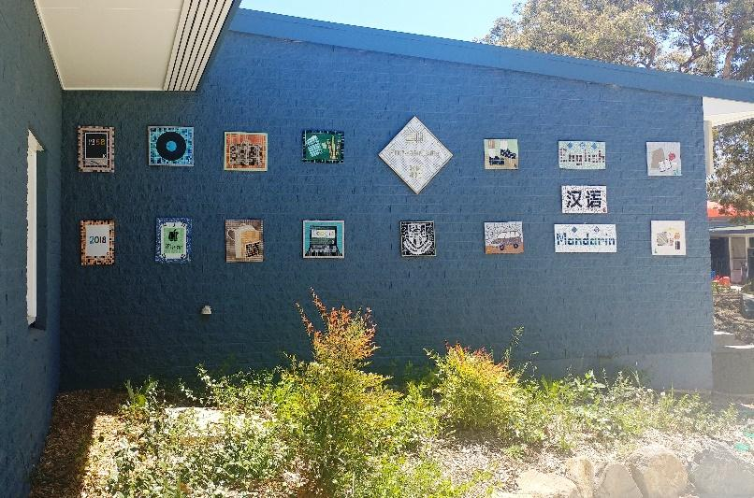

School Policies
Our policies reflect the school’s vision of valuing education and developing quality educational programs to meet the needs of all our students. Policy development is ongoing, reflecting change in Directorate policy over time, and involves the School Board in the review and approval process.
Formal policy documents can be viewed on the school’s website at: http://www.torrensps.act.edu.au/our_school/policies_and_procedures

Student Management
The school strives to develop in students the ability to work as a member of a team as well as working independently, to develop an appreciation of the worth of individual differences, and to develop the capacity to act as responsible citizens who care about others and their environment. Appropriate behaviour and good manners are always expected.
Teachers regularly monitor their programs to ensure positive behavior outcomes for their students. When normal classroom strategies such as redirection through questioning have not resulted in appropriate behavior choices, additional steps such as time out in class, time out in another classroom and time out with an Executive are implemented.
Each child’s circumstances are unique and are compassionately considered.

Positive Behaviours for Learning (PBL)
Positive behaviours for learning are encouraged at Torrens Primary School. Students, staff and families agree that we will be:
SAFE
RESPECTFUL
LEARNERS
in all settings.
Students are explicitly taught the behaviours expected of them. Every fortnight a new video is created by staff and students highlighting the three PBL core values. This whole of school approach builds shared understanding and a common language.

Home Learning
At Torrens Primary School, we value the learning that happens in the home. We recognise the busy lives that families have. As such we encourage all students to read each day and to use other time to do things together as a family. This could include sport, cooking, dancing or music. In addition to this, at times, unfinished work may be sent home for completion.

Sun Protection
Students are encouraged to use protective sunscreen and to wear hats when spending time outdoors. Wherever possible the school aims to minimize outdoor activities in the middle of the day. Parents are encouraged to apply SPF30+ sunscreen at the beginning of the school day and to provide a broad brimmed hat (preferably black or red). The school has a ‘no hat, play in the shade’ policy (all year, except in June and July) in line with Directorate policy.

Dress Standard and Colour Code Policy
The school colour code or uniform reflects community standards and are consistent with occupational health and safety, anti-discrimination, equal opportunity legislation and the Directorate’s Sun Protection policy.
All students are expected to wear school uniform and take pride in being a part of Torrens Primary School. Where uniform is not available for some reason, it is desirable that students wear plain clothing (i.e. no commercial logos) in the school colours of red and black.
The Torrens Primary School uniform (i.e. bearing Torrens Logo) or items of plain clothing (i.e. no commercial logos) consist of:
- black shorts, skort, cotton long pants/trousers or tracksuit pants
- red sweatshirt, polo top, long-sleeved polo
- red hooded sweatshirt, zipper jacket or red and black sports jacket
- Torrens Primary School summer or winter dresses
- black or white socks
- enclosed shoes/runners (no commercial logos)
- black or red broad-brimmed or bucket hat
Students are reminded of the school dress standard through class meetings and assemblies, as well as individually when required. Students will not be disadvantaged where required dress standards are not available because of circumstances beyond their control.

Information Communication Technology (ICT)
Students are introduced to technology in a safe environment where they are taught to discriminate between relevant and irrelevant information, cite online sources and share knowledge and information respectfully using appropriate language for the online environment.
Computer network and internet: Students are provided with a computer network account and internet access. Students must abide by the Directorate’s Acceptable Use of Information Technology policy when accessing public or Directorate network, internet and email services.
Online services: The Directorate provides students with safe and secure access to a range of online learning platforms for students through an online portal called the Digital Backpack. Services requiring personally identifiable student information to be stored outside of the Directorate will only be made available after parental consent.
More information, including the Directorate’s Acceptable Use of Information Technology policy can be found at:
https://www.education.act.gov.au/public-school-life/learn-anywhere-ict-for-students/resources-anywhere-digital-backpack
Bring your own device (BYOD) procedures: To prepare students for high school and involvement in a technological world, Personal Electronic Devices (PEDs) may be used as part of educational learning programs, in line with Directorate policy (Use of Personal Electronic Devices (PEDS) in School Policy 2015 and the Communities Online: Acceptable Use of ICT – Parents and Students Policy 2013). The procedure outline follows.
- The school will provide a PED to a student. They do not have to have their own.
- Students will be required to familiarise themselves and sign the Acceptable Use of ICT Student Agreement prior to using their PED.
- Students and their parents must complete and return a signed Acceptable Use of PEDs Student Agreement before students can participate in the school’s use of PEDs program.
- Torrens Primary School provides a WiFi network which students can connect to while using their devices at school.
- Students and/or their families are responsible for their personal computing devices at all times. Torrens Primary School does not have the technology support staff to repair or update personal computing devices.
- Torrens Primary School takes no liability for damaged, lost or stolen personal computing devices.
- Learning activities may be worked on or completed at home. This will be optional.
- Students will be encouraged to store their work on their Google Apps for Education accounts.
- Students are responsible for managing the battery life of their PED and should ensure that devices are fully charged every morning. Schools are not responsible for providing PED charging facilities.

Administration

School Hours, Before and After School Care

Day: 9.15am -3.15pm

Session 1: 9.15am-11.00am

Recess: 11.00am-11.30am

Session 2: 11.30am-1.00pm

Lunch: 1.00pm-1.40pm

Session 3: 1.40-3.15pm

Children should not arrive at school before 8.45am as staff are preparing for their teaching day and there is no playground supervision before this time. Woden Community Services (WCS) operates a Before School Care Program on school premises from 7.30am.
Children should be picked up promptly at the end of the day as there is no playground supervision after 3.15pm. WCS also operates an After School Care Program at school from 3.15pm until 6pm.
Contact details for WCS Out of School Hours Care (OSHC) program at Torrens: Phone (02) 6147 3318; email enrolments@wcs.org.au or oshc@wcs.org.au ; web https://www.wcs.org.au/childcare/out-of-school-hours-care

School Organisation and Houses

The Junior School: Preschool, Kindergarten, Year 1 and Year 2

The Senior School: Years’ 3 to 6

House groups: Children in Kindy to Year 6 also belong in one of four (4) ‘colour’ Houses in which they compete to earn house points in the school’s annual swimming and athletics carnivals. To maintain peace and harmony in the household, siblings are placed in the same House group. Houses are Fraser (red); Wenden (blue); Clarke (green), and Devlin (yellow). Children can wear house colours on carnival days.

School Uniform

The School Board endorses the wearing of the school uniform or the school colours of red and black. Children attending excursions or outside events should be in full school uniform or school colours, unless otherwise stated. Refer to page 18 of this handbook for the full school dress standard and colour code policy.
Uniform pieces bearing the school’s logo and the summer and winter dresses are stocked by Lowes Tuggeranong (Cnr of Anketell and Reed Streets; w: lowes.com.au ). The Torrens P&C also operates a uniform shop at the school offering good quality secondhand items bearing the Torrens logo. Opening times for this shop are advertised each week in the online school newsletter.

Stationery Requirements/Book Packs

Each year in Term 4, stationery lists for the following school year are issued, together with instructions for ordering and online payment direct to the supplier.

You do not need to purchase all or any of the items on the list from the school’s Directorate-appointed supplier, however if you do choose to buy from elsewhere, we ask that you buy items of equivalent quality. Please note that delivery of items is to your home address and not the school’s address.

Attendance, absences and pick up during school hours

All absences from school must be reported in a timely manner. To report absences, please only use the following points of contact:

Front Office phone: (02) 6142 0777
Front Office email: admin@torrensps.act.edu.au
Online absence form: https://torrensps.schoolzineplus.com/form/3

Please do not use Seesaw or email teachers directly to communicate absences as this will not ensure timeliness and accuracy of absence reporting.

If your child arrives at school after 9.15am, you are required to bring them into school via the Front Office so that their late arrival can be noted on the electronic roll.

If you need to pick your child up early from school or during school hours (e.g. for an appointment) you are required to sign them out at the Front Office and obtain a partial absence receipt for the teacher. A child will not be released from the classroom by the teacher without this notification from the Front Office. If your child is returning to school after an appointment, you are also required to sign them back in at the Front Office.

Please keep your contact details, and those of your nominated emergency contacts, up to date so that Front Office staff can provide the partial absence receipt in a timely fashion.

Appointments with teachers

Staff are aware of the importance of maintaining close contact with families. Important and useful information is often shared at the beginning and the end of the school day. Please be mindful that staff need to be ready to teach at 9.15am and some will have supervising duties from 8.45am and again at 3.15pm when children are leaving school. Staff also have meeting commitments on some afternoons from 3.15pm. It would be greatly appreciated if you make appointments with teachers via the Front Office either by phoning (02)6142 0777 or sending an email to admin@torrensps.act.edu.au.

Assemblies

Whole school assemblies are usually held fortnightly on Fridays at 12.15pm, in the Old Hall. Individual classes or year groups take turns to host assemblies and you will be given lots of notice if your child is participating. Assemblies are an opportunity for students to showcase work and perform items such as plays, dances and instrumental or choral pieces.

Special assemblies are held to celebrate Harmony Day, ANZAC Day, NAIDOC week, Book Week, Just 50 Words Literacy and Year 6 Graduation, as well as the wonderful sporting, academic and citizenship achievements of our students. Special assemblies may be held on days other than Fridays, or at different times to regular assemblies. You can check the school newsletter each week and the website calendar for confirmation of assembly arrangements.

Buses

Bus routes, timetables and information regarding the MyWay travel card can be found on the Transport Canberra website at https://www.transport.act.gov.au/ , or by phoning 13 17 10. If your child needs to catch a bus home from school, please let the Front Office know so that their name can be added to the bus list. Staff are rostered on to bus duty each afternoon.

Food during the day – Health Break, Recess, Lunch, filled water (only) bottle

At Torrens Primary school children are encouraged to bring healthy food for a health break in the classroom, at Recess (11am) and at Lunchtime (1pm). They should also bring a filled water (only) bottle from home each day. Please note: Torrens Primary School is a nut and allergy aware school due to the possible attendance of students with life threatening anaphylactic allergic conditions.

Library

The library resource centre is an integral part of the school’s teaching and learning program. It provides a rich literary environment for all students. Regular lessons develop literature appreciation and research skills. Each class has a rostered time to use the library to borrow books, use materials, catalogues and equipment. The library is also open during certain lunch times as part of the Clubs Program operated by the school.

Lost Property

Labelling your child’s clothing and other possessions will help ensure that anything that is lost can be returned to you. Lost property is collected in containers in both junior and senior corridors at school. Parents can look through the collections if required. The P&C aims to sort the items each term and return any named items. Unclaimed items may be either donated to the second-hand uniform store or charity.

Messages, deliveries, money collection

To ensure interruptions are kept to a minimum, parents and carers bringing messages, lunches or materials to school during the day should leave them at the Front Office and staff will ensure that they are delivered. Please note however that mobile phones are not permitted to be used by students during the day and if they are brought to school, phones must be left in bags until the end of the day.

Any permission notes sent to school should be handed to the classroom teacher first thing in the morning or put in the box at the Front Office.

You can make payments online for most things via the payment portal on the school website, or make an Eftpos payment at the Front Office, avoiding any need to send your child to school with cash.

Newsletter and notes home

The main form of communication between the school and home is the weekly online newsletter, the Torrens Times. This is posted on the school website every Thursday during term time. For sustainability reasons, the newsletter link is emailed home. You are encouraged to keep your preferred email address up to date on our records so that you receive the weekly newsletter. Make sure you take note in the newsletter of upcoming events and excursions and when permission notes and any payments are due.

Wherever possible, notes for incursions and some excursions will go home online (via your preferred email address). You will be able to return completed incursion and some excursion notes and make payment online in a more stream-lined service. Other notes will still come home in your child’s bag so make a habit of checking this regularly. You are encouraged to download copies of missed notes from the school website and make use of the online system where at all possible. Messages and urgent reminders may also be posted on Seesaw or sent as a text message to your mobile phone. Please therefore ensure that you notify us of any changes to your mobile phone number.

Parking and road safety around the school

Families are reminded to always park legally and drive safely around the school.
Parking illegally, which includes parking on nature strips, footpaths, verges, street corners and on children’s crossings, reduces safety for children as they enter and exit the school each day. This includes the area outside Gate 3 on Ritchie Street which is highly frequented by children.
Parking Operations use a Licence Plate Recognition vehicle (or electronic chalking) and regularly patrol school zones to increase safety for children. Fines are often issued for parking related offences.
Try parking a little further from the school and walking to meet your child or arrange a meeting point with your child so they can walk to meet you. It’s a great way to avoid illegal parking and helps children to receive the recommended 60 minutes of physical activity every day.
Road safety near the school is everyone’s responsibility. Please remember to drive slowly, park legally and be alert for children at all times.

Updating your personal information

To facilitate speedy contact with parents in an emergency, any change in mobile phone numbers, home addresses, email addresses or details for nominated emergency contacts must be notified immediately.

Visitors, Volunteers and Parents

It is a Directorate requirement that all visitors to the school should enter via the front gate, sign in and out at the Front Office (except for attending school assemblies or whole school events). Volunteers visiting the school on a regular basis are required to have a valid Working with Vulnerable People card. Refer to page 15 of this handbook for more information on volunteering at Torrens Primary School. You can also access a volunteer nomination form and other information on our website (https://www.torrensps.act.edu.au/our_community/literacy_and_numeracy_helpers).

Website www.torrensps.act.edu.au
The school website is your ‘go to’ place for the most up to date information about happenings at Torrens Primary School. You are encouraged to view it on a regular basis for the school newsletter (Thursdays), calendar of events, class notes and making online payments. You can also subscribe to our calendar feed (by clicking on the subscribe to events feed link -https://www.torrensps.act.edu.au/our_school/icalendar_sync).
You can find all the information contained in this handbook and your pack on the website by visiting the New To Torrens Primary School tab (https://www.torrensps.act.edu.au/our_school/organisation).
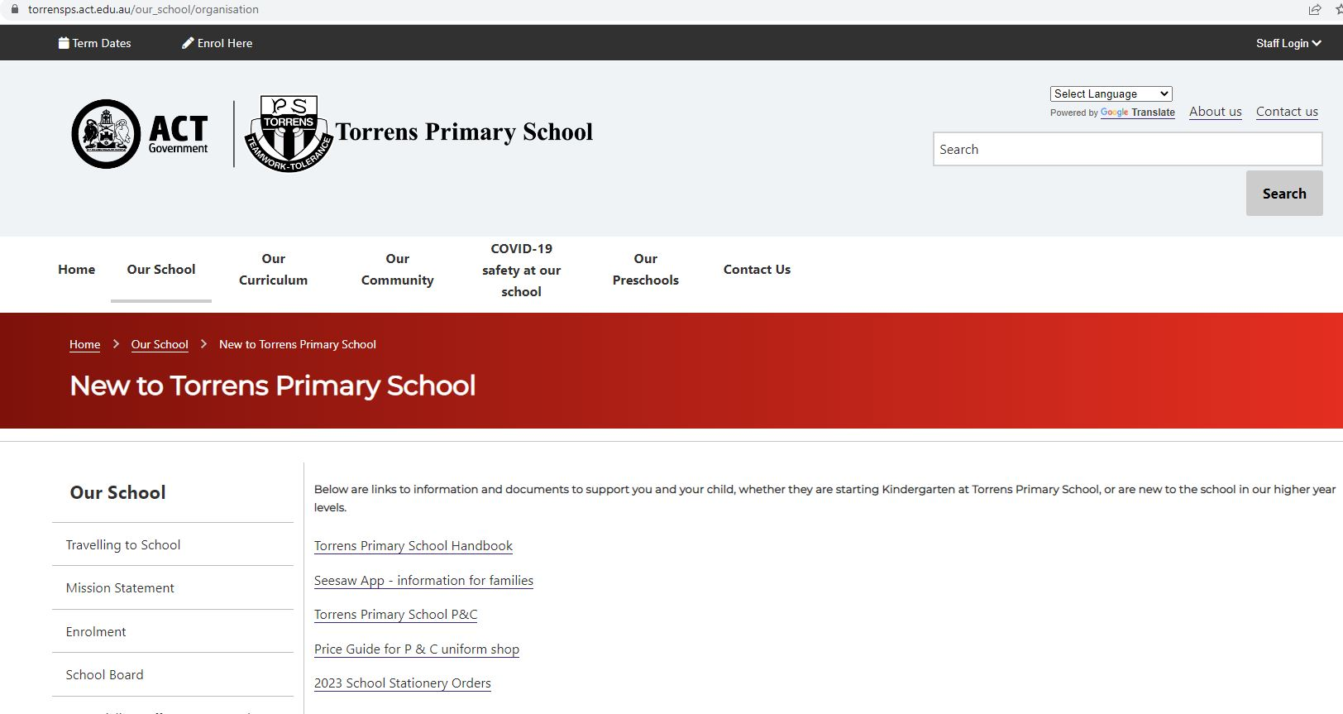

Notes

