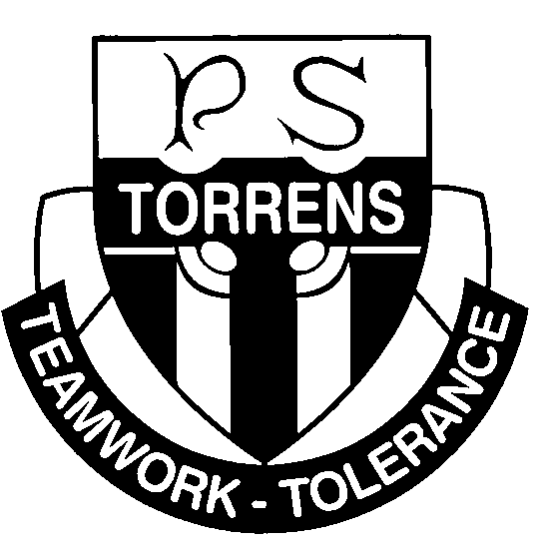
Torrens Primary School
Ritchie Street TORRENS ACT 2607
Ph: 6142 0777 admin@torrensps.act.edu.au www.torrensps.act.edu.au
2022 Wakakirri Story Festival - Expression of Interest

Dear Parents and Carers,

Torrens Primary School is excited to again participate in the Wakakirri Story Festival. Students in Year 4 and 5 are invited to take part in our performance.

Wakakirri is a storytelling festival that aims to be a positive influence for children across Australia and, ultimately, to provide them with the artistic and creative opportunities they deserve through the performing arts. For more information on the Wakakirri Festival please refer to the website https://www.wakakirri.com
Students not participating directly in the Wakakirri program will be involved in a complimentary arts program. This program may involve the preparation of props and the painting of sets. Choosing to be in Wakakirri is a commitment to a total team effort. Many hours of hard work go into putting on a Wakakirri performance and it is therefore important that children who choose to be involved stay with the program through to the performance day.
Wakakirri is aiming to run the festival as it has in the past with live audience evening performances. This will, however, be dependent on prevailing Covid-19 restrictions. The shows will also be live streamed. Live streaming will occur even if there is a live audience performance.

When and Where?

Dates for Wakakirri 2022 have not been finalised, however August 1 – 4 2022 (Term 3) has been tentatively booked. Once dates are finalised we will let you know.

If the festival can run with live shows, a full-dress rehearsal will be held at the Canberra Theatre on the day of our evening heat performance. Buses will be organised to transport the children to and from the theatre for the rehearsal. Parents will need to organise transport for their child for evening performances.

Finals will be held later in the term. Once the date for this has been announced we will pass this information on. If we make it into finals the same travel arrangements will apply for both rehearsal and evening performances.

Please turn over page for more important information

Assistance

A great deal of work goes into preparing for a Wakakirri performance. We are always looking for assistance with sewing costumes and making props and sets. Each year we also ask for volunteers with a truck or large covered trailer to assist with transporting sets and props on the day of our performance. If you can assist in any way, please let us know on the attached form.

Participation cost

Torrens Primary School supports this endeavour, however due to the cost of putting on a performance of this size and quality, it is necessary to have our families contribute to costs. An amount of $85 will be collected from each student participating in Wakakirri. This will cover travel by bus to and from the Canberra Theatre ($20 per student), Wakakirri participation fees including insurance ($35 per student) and the cost of materials for costumes, makeup and props ($30 per student). Please note there will be an additional cost for Canberra Theatre tickets, should the evening performances be open to the public.

Limited participation numbers in 2022

This year we will be offering the Wakakirri program to 80 students from Years’ 4 and 5 only. This is to ensure that if Wakakirri is required to restrict participant numbers due to Covid-19 we are still able to perform. The first 80 students to return their notes and pay the $85 participation fee will be offered a place. We understand that this is different to how we have run the program in the past, however last year Wakakirri had to limit participant numbers just before our performance. We have decided to limit our participant numbers in line with the Covid restrictions at the Canberra Theatre.

Please complete the attached participation permission and assistance form and the official Wakakirri Permission and Publicity form and return them to the mailbox at the Front Office. Notes and payment will need to be finalised by Thursday 7 April (Week 10).

We thank you for your support and look forward to another positive and rewarding Wakakirri experience.

The Torrens Wakakirri Team
Torrens Primary School
Ritchie Street TORRENS ACT 2607
Phone: 6142 0777 admin@torrensps.act.edu.au www.torrensps.act.edu.au

2022 Wakakirri Story Festival - Participation Permission

Return completed forms to Front Office mailbox as soon as possible:

- My child (name) ________________________________ in (class)_______ would like to participate in the 2022 Torrens Primary School Wakakirri Performance.

- I enclose the completed Wakakirri official permission and publicity form.

- Shirt and pant sizes are required for costuming. Please fill out appropriate sizes in the boxes:

Shirt size Pant size

- I understand I will be asked to pay the $85 participation cost by Thursday, 7 April (Week 10).

Parent / Carer Name: ________________________________________________________________________________________
Signature: ____________________________________________________________ Date: ______/_____/______

I/we can assist with Wakakirri by (please circle all that apply):

Sewing costumes Assembling/Painting props/ backdrops Fundraising
Hair and Make-up Transporting backdrops and props

Please specify if you have any expertise in building sets etc, or if you have access to a vehicle large enough to transport props and backdrops.

Name(s) ______________________________ ______________________________

Contact mobile number(s)_____________________ ________________________

