**Torrens Primary School** Ritchie Street TORRENS A.C.T. 2607

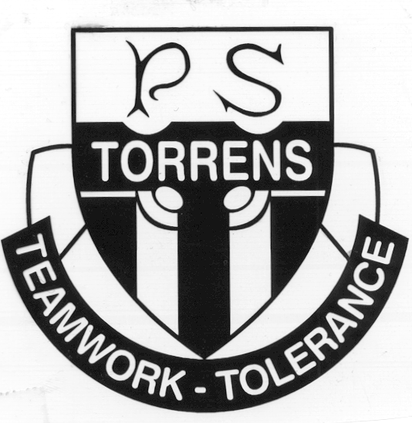

6142 0777 [admin@torrensps.act.edu.au](mailto:admin@torrensps.act.edu.au) www.torrensps.act.edu.au

**Whole School (K-6) Term 3 2022 - In school Performances**

**Total Cost:** $8 for both performances -*The school has made every effort to keep cost for these incursions at a minimum level. If necessary, parents or carers can confidentially discuss support to meet this cost with the Principal. Please contact the Front Office if you would like to speak with the Principal.*

**Payment and Permission due:** Friday 22 July 2022 (Week 1, Term 3)

*-------------------------------------------------------------------------------------------------------------------------------*

**Performance 1: Jarrod Hoare – Japanese Performing Artist - Tuesday 26 July (Week 2)**

**To enrich our learning of Japanese, Torrens Primary School will host a performance by Jarrod Hoare.** Jarrod educates and inspires through performing arts, specializing in traditional Japanese comic theatre (Kyōgen) and traditional comic storytelling (Rakugo), which he studied in Japan. Performances are interactive and suited to the needs of students. Jarrod’s passion lies in developing bridges of cultural and artistic exchange between Australia and Japan.

**Performance 2: Books To Life performance of ‘The Imagineer’ - Tuesday 16 August (Week 5)**

**As part of our Book Week celebrations and learning around the Children’s Book Council of Australia (CBCA) Shortlist of high quality Australian books in Term 3, Torrens Primary School is excited to be hosting Books to Life – a performance of the book “The Imagineer” by Christopher Cheng and Lucia Masciullo, a notable-listed book for CBCA Picture Book of the Year.   
This live and interactive show includes dance, drama, music, puppetry, painted sets, digital projections, coloured and raised staging with professional sound system, audience participation and a Q&A session.**

Please complete permission for both performances below and make payment by end of Week 1 Term 3.

------------------------------------------------------------------------------------------------------------------------------

**Permission**

I give permission for my child to attend the Term 3 In School performances. Please tick (√) -

□ Interactive Japanese Performing Artist, Rakugo and Kyogen - Tuesday 26 July (Week 2)

□ Books to Life Performance of ‘The Imagineer’ - Tuesday 16 August (Week 5)

Child’s Name: ____________________________________________________Class: ________

Name of Parent /Carer (Please print) _______________________________________________

Signature: _______________________________________ Date: *____ /_____/_____*

**-------------------------------------------------------------------------------------------------------------------------------------------------------**

**Payment - $8 -** Online or EFTPOS preferred

□ On-line ([www.torrensps.act.edu.au/payment](http://www.torrensps.act.edu.au/payment)) Receipt No. ______________ *or*

□ EFTPOS __/__/__ (please call 61420777 to make EFTPOS payment)