**Torrens Primary School** Ritchie Street TORRENS A.C.T. 2607



6142 0777 [admin@torrensps.act.edu.au](mailto:admin@torrensps.act.edu.au) www.torrensps.act.edu.au

**Japanese Incursion:**  Kenny Chan, Manga Artist

**Group:** Year 3 to Year 6 students, and Teaching staff

**Staff/Student ratio:** 1:16

**When:** Tuesday 6 September 2022 (Week 8)

**Cost:** $6

*The school has made every effort to keep cost for this incursion at a minimum level. If necessary, parents or carers can confidentially discuss support to meet this cost with the Principal. Please contact the Front Office if you would like to speak with the Principal.*

**Payment and Permission due:** Monday 5 September*(Online or EFTPOS preferred)*

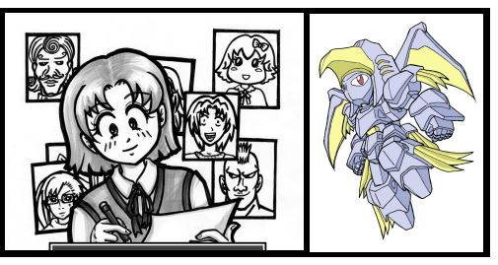

*-------------------------------------------------------------------------------------------------------------------------------*

**Purpose:**

**To enrich our learning of Japanese, Torrens Primary School will host a visit from professional manga artist** Kenny Chan. He will show students how to draw manga! Kenny, a renowned manga artist, teaches the nuances of each line in perfecting the drawing of manga as well as the use of manga in Japan. Kenny Chan is a registered teacher with the Victorian Institute of Education and has been running classes in the Japanese manga comic form around Victoria for 15 years. He has previously worked as a freelance artist and animator in comics, video games and movies.

------------------------------------------------------------------------------------------------------------------------------

**Permission *– return to class teacher***

I give permission for my child to attend the Kenny Chan, Manga Artist Japanese incursion on Tuesday, 6 September 2022 (Week 8).

Child’s Name: ____________________________________________________Class: ________

Name of Parent /Carer (Please print) _______________________________________________

Signature: _______________________________________ Date: *____ /_____/______*

**Payment - $6**

□ On-line ([www.torrensps.act.edu.au/payment](http://www.torrensps.act.edu.au/payment)) Receipt No. ______________ *or*

□ EFTPOS payment date __/__/__ (please call 61420777 to make EFTPOS payment)